Final Project Review Report
[2019-2022]

United Nations Development Programme Turkmenistan
Project title “Strengthening the Trade Capacity of Turkmenistan”
Project ID: 00097116
Output ID: 00100961
Project Duration: 01.05.2019-30.04.2021
Extension(s): 30.04.2021-31.12.2021; 01.01.2022-31.03.2022
Implementing Partner: Ministry of Trade and Foreign Economic Relations of
Turkmenistan
Total Budget: USD 468, 175.00
Government Cost-Sharing: USD 444, 175.00
UNDP Fund: USD 24, 000.00
CO Focal Points: Akmyrat Danatarov, Programme Specialist
The main objective of the project was to strengthen the capacity of the country through the development of human capital in order to increase the competitiveness of national staff and transform human intelligence into the leading factor of economic growth and national competitiveness, diversification of export and increasing the share of higher-value added products in export composition, and lowering the share of import in the national economy.

The project included the following components: 1) Strengthening institutional and personnel trade capacity; 2) Building capacity to formulate and implement trade-related policy measures; and 3) Strengthening the applied scientific research capacity and improving the quality of education.

SUMMARY
In recent years, there has been many developments in the economy of Turkmenistan that have a positive impact on strengthening trade capacity of the country. Developing companies successfully competing in the domestic market and exporting products abroad have been established. Several investment projects have been implemented in the territory of Turkmenistan, which have created new jobs. Impressive results have been achieved in certain sectors of country’s economy, for example, in the construction sector. Several other sectors, such as textile and chemical industry, demonstrate potential for growth. Economic governance system is being formed based on both state-owned and private enterprises.
According to the Presidential Programme for Socio-Economic Development for 2018-2024, import substitution and export diversification should be the top priorities for strengthening the competitiveness of a national economy in the coming years. In addition, there are two key government programmes being currently implemented in the country, which promote economic diversification: 1) on production of import-substituting goods, and 2) on increasing the production of export-oriented goods. At the same time, the successful realization of the established goals faces several systemic challenges reflecting both global trends and domestic barriers to the development of country’s trade capacity.
In the context of growing competition with European and Asian markets the existing negative trends in terms of qualified personnel will make it extremely difficult to address the issue of reducing import dependency of country’s economy (primarily, high value-added products, such as cars and equipment), because effective import substitution implies not only purchasing the technologies, but also their further advancement. Consequently, the objective of import substitution identified by the leadership of Turkmenistan must achieved primarily through investments in human capital in order to develop qualified national personnel.
In this regard, Ministry of Trade and Foreign Economic Relations of Turkmenistan and the United Nations Development Programme in Turkmenistan developed and signed the project entitled “Strengthening the Trade Capacity of Turkmenistan for the period of 2019-2021”. The project was focused on supporting the Government of Turkmenistan in institutional and personnel capacity development by enhancing knowledge of national personnel and increasing the efficiency of using trade regulation instruments, which specified by the existing international agreements of Turkmenistan.

REVIEW OF PROGRESS AND RESULTS ACHIVED
The goal of the project was to enhance the level of competitiveness of national economy by strengthening qualification of professional staff. Strengthening qualification of national professionals directed towards training of specialists demanded by modern economy, market analysis through applied scientific research, establishment of contacts with foreign and international organizations that would sufficiently enable national professionals determining international trade policy development.

UNDP’s assistance strategy on formulation and implementation of a set of measures to build trade capacity of Turkmenistan consisted of the following components:
Component 1: “Strengthening institutional and personnel trade capacity”:
- develop human capital with a view to enhance competitiveness of national personnel and transform human intellect to the leading factor of economic growth and national competitiveness;
- increase the efficiency of using trade regulation instruments specified by the existing international agreements of Turkmenistan; to consider the relevance of legal framework as one of the necessary instruments of successful implementation of objectives to reduce import dependence and diversify export in the current international conditions; drafting the model agreements covering the issues of trade and economic cooperation. This subcomponent also included the analysis of Turkmenistan’s participation in the international multilateral and regional organizations dealing with economic issues;
Component 2: “Building capacity to formulate and implement trade-related policy measures”:
- analysis of regulatory and procedural barriers in the markets of the third countries, which prevent access of Turkmenistan products to foreign markets;
- formulation and implementation of a set of measures aimed to ensure the effective access of export of Turkmenistan to foreign markets, including introduction of organizational and economic mechanisms of formation of integrated distribution system, which can ensure effective promotion of export of national products;
- strengthening the strategy to promote goods to foreign and domestic consumer markets, which will be based on the marketing approach to business-processes and client-oriented relationship with consumers, as well as introduction of trademark registration system (branding);
Component 3: “Strengthening the applied scientific research capacity and improving the quality of education”:
- measures aimed at creating conditions for collaboration between the Research Institute of National Product Turnover under the Ministry of Trade and Foreign Economic Relations and international scientific community to access new knowledge and opportunities for cooperation in the priority research areas.
- measures aimed at enhancing the efficiency of knowledge generation areas (fundamental and applied science) and increasing the practical significance of scientific research with a view of strengthening competitiveness of economic sectors of Turkmenistan, including building trade capacity of the country.

During the project implementation phase the following results were achieved:

Result 1: Strengthening institutional and personnel trade capacity

The launch of the project was with some delays as it started in late 2019 and impact of travel restrictions of new type of virus Covid-19 in 2020 greatly impacted in implementation of planned activities for 2020 as substantial part of the project is about organizing trainings in the physical presence of international consultants. With the beginning of 2020, before exposure of COVID-19 globally, Mr. Achim Seiler, UNDP international consultant was contracted to assess training needs for development of trade policy formulation capacity of national trade organizations of Turkmenistan. The international consultant evaluated trade capacity through provision of consultations with all national project partners of Turkmenistan and assessed their needs to strengthen their capacity to formulate trade policy. As a result, international consultant proposed 5 days training module and training days were set. However, with travel restrictions, the training was postponed to later dates and shifted to 2021. Visit of Mr. Achim Seiler was reflected in following press-release: https://www.tm.undp.org/content/turkmenistan/en/home/presscenter/pressreleases/2020/UNDP-and-Ministry-of-Trade-of-Turkmenistan-Kick-off-Assessment-of-Country-Trade-Capacity.html
As per approved Annual Work Plan for the period 2019-2020, the international consultant together with national consultant provided desk work on the application of modern technology to improve domestic and foreign sales and utilization of e-marketing technologies. The training modules were set by this international consultant and provision of training either in physical presence of international consultant or in online mode was planned for 75 participants from 5 velayats. At the request of national partner, the training for velayat specialists was shifted to 2021. For national trade organizations: Ministry of Trade and Foreign Economic Relations of Turkmenistan, State Commodity and Raw Materials Exchange of Turkmenistan, Chamber of Commerce and Industry of Turkmenistan and Union of Industrialists and Entrepreneurs of Turkmenistan, the trade policy development needs were assessed through consultations. Based on needs assessment training modules were determined by international expert.
Continuing with Covid-19 restrictions into 2021, within the joint project maximum efforts being applied to implement activities agreed for Annual Work Plan for 2021 with national partner in online mode. During May 2021, in hybrid format 3 days training in each region of the country with participation of international expert Mr. Ravinder Raina were organized on the application of advanced informational and marketing technologies for analyzing market and consumer behavior and organizing sale of goods for specialists of Dashoguz, Lebap, Ahal, Mary and Balkan velayats. The participants of the trainings were acquainted with basic modern marketing concepts and techniques and application of advanced technologies in trade and commerce.
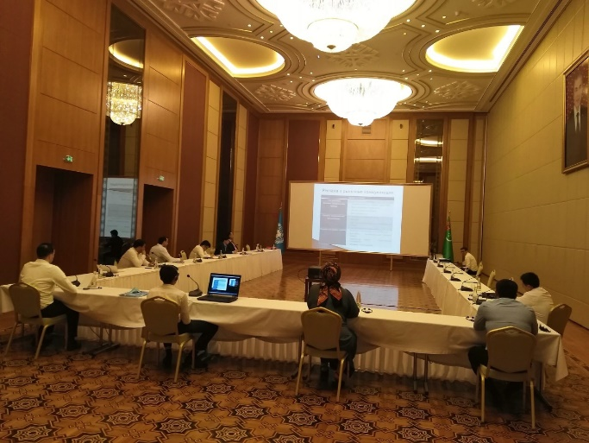
The specialists of national partners learnt the best international practices, trends and developments in e-commerce and how to develop e-commerce at individual firm and national levels. In the serious of trainings, 15 participants attended from each velayat making 75 individuals in total. Participants mainly were heads of sections and specialists of velayat departments from Turkmenistan Ministry of Trade and Foreign Economic Relations, State Commodity and Raw Materials Exchange, Chamber of Commerce and Industry, Union of Industrialists and Entrepreneurs and Ministry of Finance and Economy. At the end of training all participants received certificate of attendance. Relevant activities press release is published in following UNDP site: UNDP facilitates trade development in Turkmenistan | UNDP in Turkmenistan.
From 21-25 June 2021 in hybrid format foreign trade policy development training was organized for 36 specialists and heads of sections from the line of ministries and organizations of Turkmenistan such as Ministry of Foreign Affairs, Ministry of Trade and Foreign Economic Relations, Ministry of Finance and Economy, Ministry of Agriculture and Environmental Protection, Ministry of Industry and Construction Production, State Commodity and Raw Materials Exchange, Chamber of Commerce and Industry, Union of Industrialists and Entrepreneurs, State Customs Service, Main State Service of Turkmenistan „Turkmenstandards“. Mr. Achim Seiler, international consultant from Germany introduced the World Trade Organization and instructed participants of the training with important processes to prepare country’s reediness to WTO accession in the future. Participants of the training were exposed to the essence of formulating foreign trade policy with consideration of WTO membership. Participants of the training engaged in productive discussions with the international consultant. Mr. Seiler provided considerable amount of information and instructions for further study of WTO training and courses. The training was part of a certified course to develop trade skills of national partners. Press release on this event can be found at UNDP supports development of the country’s trade sector | UNDP in Turkmenistan.
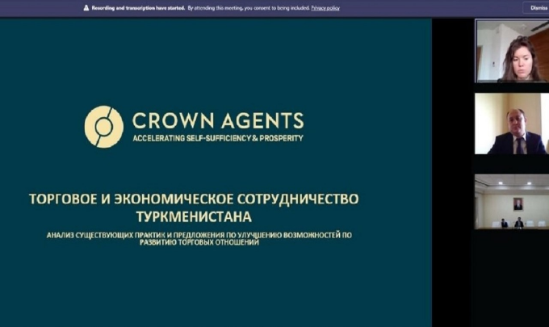
Ms. Evgenia Pomerlyan and Mr. Vladimir Trofimchuk, the international experts of British “Crown Agents“company with the support of national consultant developed proposal on improvement of practice of concluding international agreements on trade and economic cooperation on bilateral, regional and multilateral basis. Online seminar was held on 12th of October 2021 to present proposal to national partners. The event coverage for press release can be viewed at UNDP supports improvement of practices of concluding international agreements on trade and economic cooperation | UNDP in Turkmenistan. In cooperation with national partners from the Ministry of Trade and Foreign Economic Relations, Ministry of Foreign Affairs, Ministry of Justice, Ministry of Finance and Economy, Ministry of Agriculture and Environmental Protection State Commodity and Raw Materials Exchange, Chamber of Commerce and Industry, Union of Industrialists and Entrepreneurs, State Customs Service, State Sanitary Epidemiological Services and other national partners model agreement was drafted based on the recommendations of international experts.
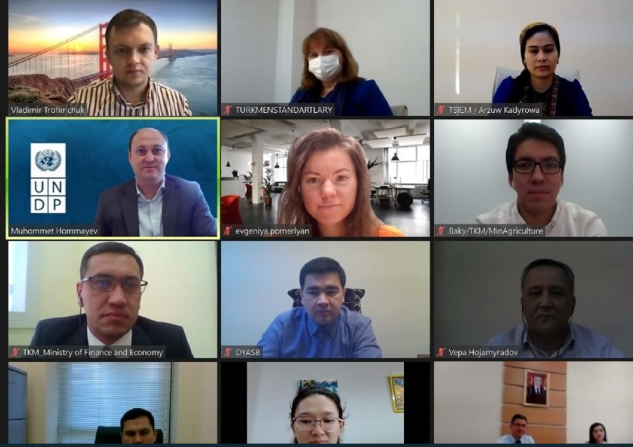
The series of online trainings on the development of trade policy skills have been held between 12-26 January 2022 with involved participation of Ms. Evgenia Pomerlyan and Mr. Vladimir Trofimchuk international consultants from the British company "Crown Agents", who facilitated the interactive discussions on such topics as the development of art of negotiation skills, conflicts and interests of individual countries/regions in the area of international trade, trade instruments and risk management, trade research and analysis skills and instruments for regulation of trade in goods and services. It was expected that the abovementioned trainings strengthened the skills of the national specialists working in the field of trade on developing the trade policy to accelerate the country’s efforts on enhancing the export potential of Turkmenistan.

Result 2: Building capacity to formulate and implement foreign trade-related policy measures

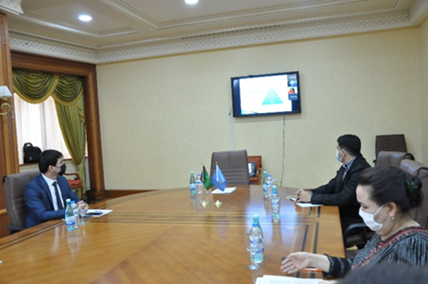
Mr. Ravinder Raina, international consultant provided a desk work for identifying best international practices on the application of advanced informational and marketing technologies and delivered in semi-online mode, five-day training from 23 – 27 November 2020 with physical presence of majority of participants in the Trade Complex Building of Turkmenistan in Ashgabat city. Total number of participants were 31 specialists mainly from the Ministry of Trade and Foreign Economic Relations of Turkmenistan, State Commodity and Raw Materials Exchange of Turkmenistan, Chamber of Commerce and Industry of Turkmenistan, Union of Industrialists and Entrepreneurs of Turkmenistan, and Ministry of Finance and Economy of Turkmenistan. Participants were acquainted with basic modern marketing concepts and techniques and application of advanced technologies in trade and commerce. National trade specialists learned international practices, trends and developments in e-commerce and how to develop e-commerce at individual firm and national levels.
Development of proposals on elimination of trade barriers and implementation of comprehensive system to support national export throughout the whole goods shipment chain; International experience and recommendations for Turkmenistan, national partner advised to conduct this activity in physical presence of international consultant in the hope that travel restrictions will be lifted in 2021. Therefore, the activity was shifted to 2021. 31 trade officials from Ashgabat city mainly from Ministry of Trade and Foreign Economic Relations of Turkmenistan, State Commodity and Raw Materials Exchange of Turkmenistan, Chamber of Commerce and Industry of Turkmenistan, Union of Industrialists and Entrepreneurs of Turkmenistan, and Ministry of Finance and Economy of Turkmenistan were trained with application of advanced informational and marketing technologies along with modern marketing concepts and techniques. For the implementation of this activity, Ms. Linda Mazure, international consultant with the support of national consultant reviewed existing practices of trademark registration in Turkmenistan and developed proposal for improving trademark registration based on the best international practices. Proposal was presented during the online seminar on 16 August 2021 with participation of the Ministry of Trade and Foreign Economic Relations, State Service for Intellectual Property of the Ministry of Finance and Economy, State Commodity and Raw Materials Exchange, Chamber of Commerce and Industry, and the Union of Industrialists and Entrepreneurs of Turkmenistan. Press release of the seminar can be found at UNDP to improve trademark registration practices | UNDP in Turkmenistan.

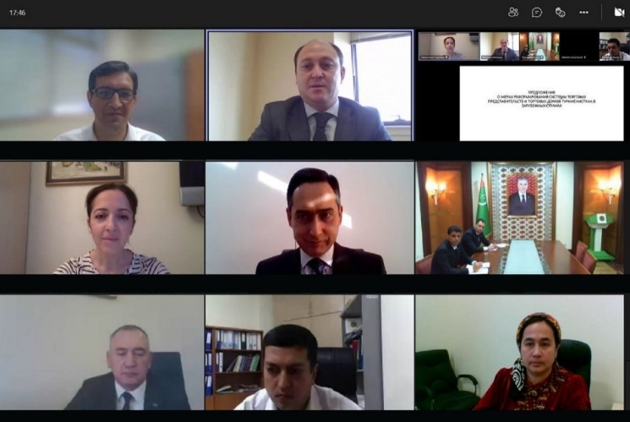
The online seminar on the provision of recommendations for improvement of the performance of trading houses abroad was held on 8 November 2021. The event was organized with participation of Ms. Anait Smbatyan, international consultant from the Russian Federation selected within the framework of “Russian Experts on Demand“ programme of UNDP Russia. Mrs. Anait Smbatyan reviewed the performance of trade houses of Turkmenistan abroad with the support of national consultant and provided with recommendations on increasing practical results of activities of trade houses located abroad. As a result, Mrs. Smbatyan prepared the recommendations and delivered her presentation in online seminar. The event gathered the representatives of the line ministries and entities of Turkmenistan, including the Ministry of Trade and Foreign Economic Relations, Ministry of Agriculture and Environmental Protection, Ministry of Finance and Economy, Ministry of Textile Industry, State Commodity and Raw Materials Exchange, State Customs Service, Main State Service "Turkmenstandartlary", State Bank for Foreign Economic Affairs, Chamber of Commerce and Industry, State Service for Sanitation and Disease Control and the Union of Industrialists and Entrepreneurs of Turkmenistan. Press release of the event is available at UNDP supports the improvement of trading houses performance | UNDP in Turkmenistan.

The online training on eliminating trade barriers and trade facilitation was held on 22-28 January 2022. The training sessions involved participation of the international consultant from the British company "Crown Agents" Mr. Aleksey Bondarenko, who led the interactive discussions on trade facilitation issues, including the concept of a single window, the creation of digital transport corridors, and adherence of the country to the international standards and recommendations.

Result 3: Strengthening of applied scientific research capacity

To achieve this result, the professional research organization was searched to establish potential partnership with the Research Department of the Ministry of Trade and Foreign Economic Relations of Turkmenistan. Online consultations were held with Istanbul Regional Hub of UNDP and Trade Specialist of UNDP Kyrgyzstan. Also within the project it was proposed to make portfolio of potential expert organization to arrange cooperation in trade research with national partner, respective online meetings and consultations were held between World Trade Institute of Bern, Switzerland on October 8, 2020 (for reference https://www.tm.undp.org/content/turkmenistan/en/home/presscenter/pressreleases/2020/UNDP-and-the-Ministry-of-Trade-establish-partnership-with-WTI.html ) and with National Research University Higher School of Economics of Russian Federation on December 15, 2020 (for reference: https://www.tm.undp.org/content/turkmenistan/en/home/presscenter/pressreleases/2020/UNDP-supports-Ministry-of-Trade-of-Turkmenistan-to-expand-its-partnership-network.html
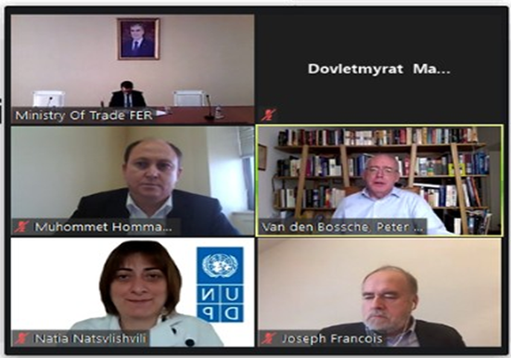
Online meetings were attended by representatives of Research and Foreign Economic Relations Departments of the Ministry of Trade and Foreign Economic Relations of Turkmenistan, UNDP, and respective foreign expert organizations. During the online meetings, it was discussion potential cooperation in trade research field between the Ministry of Trade and Foreign Economic Relations of Turkmenistan and globally and regionally well recognized research institutes.
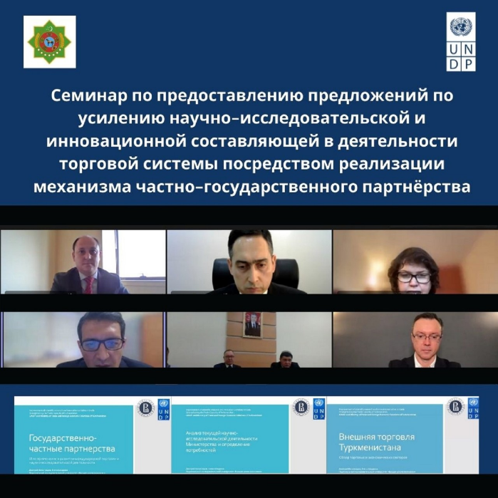
The proposals on strengthening research and innovation component of Ministry of Trade and Foreign Economic Relations of Turkmenistan through implementation of public-private partnership mechanism was provided. The online seminar on improving the scientific-research and innovation activities in trade through the implementation of the public-private partnership mechanism was held on 24 November 2021 and was organized with participation of the international experts from the National Research University "Higher School of Economics” of the Russian Federation. Ms. Elena Shadrina and Mr. Dmitri Vinogradov, the international experts in cooperation with national consultant familiarized participants with the international best practices and recommendations for strengthening the research and innovation component of the trading system through the implementation of a public-private partnership mechanism. Proposals developed by international experts of “Higher School of Economics“ were presented in the online seminar. Ministry of Trade and Foreign Economic Relations, Ministry of Finance and Economy, Ministry of Education, State Commodity and Raw Materials Exchange, Chamber of Commerce and Industry and the Union of Industrialists and Entrepreneurs of Turkmenistan participated in the event. Press release of the online seminar available at UNDP improves the scientific-research and innovation activities in trade | UNDP in Turkmenistan.

PERFORMANCE REVIEW
- The project contributes to implementation of Partnership Framework for Development for the period 2016-2020 (PFD) Outcome 7: Strategies and simplified regulations are in place to promote inclusive employment through sustainable economic diversification
- Output: Growth and development are inclusive and sustainable, incorporating productive capacities that create employment and livelihoods for the poor and excluded.
- Outcome indicators as stated in the Country Programme results matrix, including baseline and targets:
- Indicator 8.4.1. Number of enhanced and simplified legal instruments (or measures), bylaws to facilitate import, export and free movement of goods across the border.
- Baseline: Plans are in place to develop programmes facilitating import and export.
- Target indicator: 4
- Indicator 8.4.2. Number of state, sectoral, regional programs including on SME development aimed at piloting new initiatives related to economic diversification at national and subnational levels.
- Baseline: One national programme on development of entrepreneurship in the industrial sectors of economy.
- Target indicator: 3

Project  output | Project output indicator | Achievements against indicators
Output 1:  Strengthening institutional and personnel trade capacity | 1.1 Number of specialists, who have completed certified course on professional development in the area of international trade | 60 specialists
 | 1.2 Practice of concluding international trade agreements on bilateral, regional and multilateral basis | yes
Output 2:  Building capacity to formulate and implement foreign trade-related policy measures | 2.1. Improving consumer market management system. International experience and recommendations for Turkmenistan | yes
 | 2.2. Capacity building of national staff on application of advanced informational and marketing technologies for analyzing market and consumer behavior | 31 specialists
 | 2.3 Review and preparation of proposals on improvement of trademark registration practice | yes
 | 2.4 Recommendations on increasing practical results of activities of trade houses/representations abroad have been prepared | yes
Output 3:  Applied scientific research capacity has been strengthened | 3.1 Proposals on strengthening of research and innovation component | yes
 | 3.2 Preparation of proposals on concluding agreements between the Ministry of Trade and Foreign Economic Relations of Turkmenistan and foreign research and expert organizations | cancelled*
 | 3.3. Training programmes (according to the approved list) on training of national staff have been prepared | cancelled*

Output indicators 3.2. and 3.3. of Result 3 were requested to be cancelled by the national partner as those activities were no longer under direct work carried by the Ministry of Trade and Foreign Economic Relations of Turkmenistan.

COMMUNICATION AND PUBLICITY
Press releases and articles on effective project implementation were published on the UNDP Turkmenistan website and other mass media sources, see enclosed links for the communication activities that received media coverage, such as trainings, seminars, round tables and etc.:
https://turkmenportal.com/en/blog/43765/mechanisms-of-trade-facilitation-considered-at-the-online-training-in-ashgabat
https://ashgabat.in/2022/01/28/v-turkmenistane-proshyol-trening-po-ukrepleniyu-potenciala-v-oblasti-uproshheniya-procedur-torgovli/
https://arzuw.news/v-turkmenistane-rassmotreli-osobennosti-uproshhenija-torgovyh-procedur
https://orient.tm/ru/post/36066/uproshchenie-procedur-torgovli-tema-ocherednogo-treninga-ot-proon
https://centralasia.news/13508-proon-provela-v-ashhabade-treningi-po-uproscheniju-procedur-torgovli.html
https://sng.today/ashkhabad/21177-na-ocherednom-treninge-proon-obsuzhdeny-voprosy-po-oblegcheniju-torgovyh-procedur.html?utm_source=yxnews&utm_medium=desktop
https://yandex.ru/news/story/PROON_provela_vAshkhabade_treningi_pouproshheniyu_procedur_torgovli--3bfb246533b753dbfa777fbac7a05820
https://www.tm.undp.org/content/turkmenistan/en/home/presscenter/pressreleases/2021/undp-strengthens-the-national-capacity-on-trade-facilitation.html
UNDP Turkmenistan - Posts | Facebook
https://twitter.com/UNDPTM/status/1487002419032645633

https://www.tm.undp.org/content/turkmenistan/en/home/presscenter/pressreleases/2020/UNDP-supports-Ministry-of-Trade-of-Turkmenistan-to-expand-its-partnership-network.html

https://www.tm.undp.org/content/turkmenistan/en/home/presscenter/pressreleases/2020/UNDP-and-Ministry-of-Trade-conduct-five-day-training.html

https://www.tm.undp.org/content/turkmenistan/en/home/presscenter/pressreleases/2020/UNDP-and-the-Ministry-of-Trade-establish-partnership-with-WTI.html

https://www.tm.undp.org/content/turkmenistan/en/home/presscenter/pressreleases/2020/UNDP-promotes-advanced-information-and-marketing-technologies-in-trade.html

https://www.tm.undp.org/content/turkmenistan/en/home/presscenter/pressreleases/2020/UNDP-and-Ministry-of-Trade-of-Turkmenistan-Kick-off-Assessment-of-Country-Trade-Capacity.html

https://www.tm.undp.org/content/turkmenistan/en/home/presscenter/pressreleases/2019/UNDP-and-Ministry-of-Trade-and-Foreign-Economic-Relations-of-Turkmenistan-Launch-New-Project.html

SUSTAINABILITY OF RESULTS
In 2020 Turkmenistan was granted an observer status at WTO, and in 2021 the Government officially applied for WTO membership. Moreover, the Government adopted a Foreign Trade Strategy for 2021-2030, which indicates two periods for WTO accession: first period is 2021-2025 for preparation work, and 2026-2030 for accession. CO has supported promotion of trade policies with trade related organizations for WTO accession issues. Trade capacity assessment has been conducted and based on government needs and assessment of trade capacity level, several trainings have been conducted in trade policy areas such as WTO accession issues, application of modern informational technologies in trade, promotion of domestic sales and improvement of export capacity. Furthermore, at institutional level, to access to new knowledge and updated databases, improve trade research capacity, online consultations have been conducted between Ministry of Trade and Foreign Economic Relations of Turkmenistan and the World Trade Institute of Bern and National Research University of Higher School of Economics of Russia. Potential to develop partnership between respective trade institutions and foreign expert organizations have been explored and prepared. Therefore, the CO strategic engagement is timely and appropriate to capitalize on previous relationship with the Ministry of Trade. This strategic position was agreed during the meeting between UNDP Resident Representative in Turkmenistan and the Minister of Trade and Foreign Economic Relations, it was decided to draft the next phase of the partnership with more concrete interventions related to current needs of the Ministry, including WTO accession, digitalization for trade facilitation, and best practices on public procurement.

IMPLEMENTATION RISKS
# | Description | Date Identified | Type | Impact &  Probability | Countermeasures / Mngt response | Owner | Submitted, updated by | Last Update | Status
1 | Non payment of due financial transaction in the sum of USD 90,590 (1st USD installment) and USD 102,714 (2nd USD installment) to UNDP Turkmenistan account as per ProDoc | 07/01/2020 | Financial | Possible delay of project implementation in case local currency is not converted into foreign currency and paid to UNDP Turkmenistan | Speeding up payment of second usd installment was requested during Project Board meeting | PS | PM | 30/06/2021 | Resolved
2 | Slight lagging in implementation of 2019 targets behind the project schedule as prescribed in ProDoc | 07/01/2020 | Operational | Risk for implementing project activities as planned in Project Document | Project Board awarded prolonging the project | PS | PM | 31/12/2020
3 | Slow implementation of project activities and risk of catching up with targets as set in project planning (COVID-19 pandemic causes on conduct of quality project activities) | 01/06/2020 | Operational | Some of the planned activities may be delayed and transferred for next year | Project activities mostly planned online due to covid-19 restrictions | PS | PM | 31/10/2021 | Resolved

FINANCIAL STATUS AND UTILISATION

Table: Project Output Financials 00097116
Output ID | Project Title | Fiscal Year | Budget | Utilization | Utilization Ratio (%)
00100961 | Trade Capacity Development | 2022 | $7,774.00 | $6,440.00 | 82
00100961 | Trade Capacity Development | 2021 | $354,493.00 | $213,689.00 | 60
00100961 | Trade Capacity Development | 2020 | $104,461.00 | $82,308.00 | 79
00100961 | Trade Capacity Development | 2019 | $1,447.00 | $1,447.00 | 100
 |  | Total | 468,175.00 | $303,744

PROJECT LESSONS-LEARNED REPORT
Project Title: | Strengthening the Trade Capacity of Turkmenistan
Country: | Turkmenistan
Related CPAP Outcome | The project contributes to implementation of Partnership Framework for Development for the period 2016-2020 (PFD) Outcome 7: Strategies and simplified regulations are in place to promote inclusive employment through sustainable economic diversification  Output: Growth and development are inclusive and sustainable, incorporating productive capacities that create employment and livelihoods for the poor and excluded.  Outcome indicators as stated in the Country Programme results matrix, including baseline and targets:  - Indicator 8.4.1. Number of enhanced and simplified legal instruments (or measures), bylaws to facilitate import, export and free movement of goods across the border.  - Indicator 8.4.2. Number of state, sectoral, regional programs including on SME development aimed at piloting new initiatives related to economic diversification at national and subnational levels.
Project Description and Key Lessons-Learned
Brief description of context | In the context of growing competition with European and Asian markets the existing negative trends in terms of qualified personnel will make it extremely difficult to address the issue of reducing import dependency of country’s economy (primarily, high value-added products, such as cars and equipment), because effective import substitution implies not only purchasing the technologies, but also their further advancement. Consequently, the objective of import substitution identified by the leadership of Turkmenistan has to be achieved primarily through investments in human capital in order to develop qualified national personnel.  Due to the increasing tendency towards protectionism and intensifying international competition for markets it will not be possible to address the objective of export diversification without implementation of range of measures focused on the creation of effective system to promote domestically produced goods in export markets throughout the whole chain: producer – ultimate buyer. Currently, there are internal barriers in Turkmenistan impeding the development in this area: (1) need to improve the legal and regulatory framework, primary, international agreements in specific areas of trade and economic cooperation (for example, Turkmenistan is not a party to the CIS Free Trade Agreement); (2) need to enhance economic return of trade houses and trade representations of Turkmenistan abroad with a view to undertake more intensive efforts on promotion of domestically produced goods in the markets of relevant countries; (3) lack of access to the international scientific, analytical and statistical information, including databases and specialized periodicals; (4) need to carry out systemic work to identify and reduce barriers to trade (tariff and non-tariff measures regulating trade) concerning products of Turkmenistan in foreign markets; (5) efforts on ensuring access of specific types of products to foreign markets has unsystematic character; (6) there is no effective and common result-based cooperation between the responsible government  agencies, business and expert communities.
Brief description of project | The main objective of this project between UNDP and the Ministry of Trade and Foreign Economic Relations of Turkmenistan was building trade capacity of the country through the development of human capital in order to increase the competitiveness of national staff and transform human intelligence into the leading factor of economic growth and national competitiveness, diversification of export and increasing the share of higher-value added products in export composition, and lowering the share of import in the national economy.  In this regard, the following project components have been identified: 1) strengthening institutional and personnel trade capacity; 2) building capacity to formulate and implement trade-related policy measures; and 3) strengthening the applied scientific research capacity and improving the quality of education.
Key project successes | - The functions and tasks of the existing departments of Turkmenistan, whose competence includes trade issues (Ministry of Trade and Foreign Economic Relations, Chamber of Commerce and Industry, Union of Industrialists and Entrepreneurs) were studied.  - Practical training of national personnel was conducted and trained 142 specialists of state bodies of Turkmenistan in the field of trade.  - International experts have developed proposals and recommendations for improving the practice of concluding international agreements on trade and economic cooperation at the bilateral, regional and multilateral levels for further application.  - The legal and institutional framework for the activities of trading houses and trade missions, including the features of their functioning in the markets of specific countries, taking into account local specifics, has been studied.  - International experts have developed practical recommendations based on world best practices on the use of marketing technologies, market analysis and consumer behavior for further application.  - International experts reviewed and prepared proposals for improving the practice of registering trademarks for further application.  - International experts have developed recommendations to increase the practical impact of trading houses abroad for further application.  - The activities of the research structures of the Ministry of Trade and Foreign Economic Relations of Turkmenistan were studied and proposals were prepared to put into operation the mechanisms of public-private partnership and strengthen the scientific and innovative component in the activities of the Ministry.  - Meetings were organized for the potential for cooperation between the Ministry of Trade and Foreign Economic Relations of Turkmenistan with research and expert institutions, such as the Institute of World Trade and the Higher School of Economics, was explored for further strategic partnership.
Project shortcomings and solutions | - The CO attaches strategic importance to the partnership with the Ministry of Trade and Foreign Economic Relations despite the challenges with ongoing project on institutional and human capacity building of the trade sector entities, where the Ministry has been skeptical of the effectiveness of online events during the global pandemic. Nevertheless, given the limitations of the new reality the CO has supported the trade sector in receiving a number of strategic consultancies and recommendations on best practices related to trade facilitation, utilizing informational and marketing technologies, concluding international trade agreements, enhancing trademark registration practices, improving the effectiveness of trade houses, and applying private-public partnership in trade related R&D.
Lessons learned | - Ministry of Trade and Foreign Economic Relations of Turkmenistan is a new national partner with UNDP. As substantial part of our project was designed strengthening the institutional and human capacities of trade sector in Turkmenistan and considering covid-19 restrictions Ministry has restricted provision of online trainings. As international communities move on with digitalization, more efforts are required to bring best international practices in utilization of modern communication technologies and techniques for training specialists of trade complex of the country. It is required to adapt more methods of e-training taking local conditions into account.  - As Turkmenistan set an ambition to join WTO it was granted with an observer status to the organization. Hence, design of project and provision of corresponding trainings could be in line with strengthening the trade capacity of Turkmenistan that give sufficient knowledge to prepare for WTO membership along with capacity development.  - One of the lessons learned from this project is provision of digital infustructure among national partners. As digitalization expands globally and digital technologies are widely used, it is essential that digital equipment are available, internet communication is stable and all personal are able to work with digital technology. In accordance with the new realities, it is necessary to optimize the implementation of project activities in an online format, taking into account the wishes and interests of national partners.  - Balance of work and time allocated for training should be flexible. Flexibility to provide mobile learning and training. Hence, rather than physical gathering and taking time of governmnet officials, e-learning with and without instructor to be incorporated to projects. It is recommended expanding and deepening cooperation with educational and specialized organizations in the field of trade to further strengthen the human, institutional and research potential of the national partners.  - There is a need to continue partnerships with international organizations to implement the Foreign Trade Strategy of Turkmenistan for the period 2021-2030, taking into account the requirements of the WTO membership accession process.
Follow-up Actions | During the Final Project Review meeting between UNDP CO Turkmenistan and the Ministry of Trade and Foreign Economic Relations, it was decided to expense the minor remaining part of budget for couple of activities on digitalization.

Project Information
Award ID: | 00097116
CO Focal Points: | Akmyrat Danatarov, Programme Specialist, Governance, Economic Diversification and Inclusive Growth portfolio (akmyrat.danatarov@undp.org)
Partners: | The Ministry of Trade and Foreign Economic Relations of Turkmenistan
Project resources: | https://www.tm.undp.org/content/turkmenistan/en/home/projects/Strengthening-the-Trade-Capacity-of-Turkmenistan.html
Date: | 29.03.2022

ANNEXES:
- Project Document with Multi-Year Annual Work Plans
- Project Extensions
- Annual Project Progress Reports for 2020-2021
- Donor Report for 2020-2021
- CDR – 2019
- CDR – 2020
- CDR – 2021
- CDR-2022

